For general information about the screens used to maintain address information, see the Datatel manual “Using Demographics” in the file P:\Group\Datatel\Datatel Documentation\Core & ST Miscellaneous\Using Demographics.pdf. The Datatel manual contains general information. This document explains how we use the Datatel screens here at Wabash.

This document explains the proper procedures to be used to enter a new address or change an address for a person or organization in Colleague.

There are several possible situations involving entering and changing addresses:
- Correcting an error in an existing address.
- Entering a new address for a person. This type of address change occurs when we receive some notification that the person has a new address, such as a new home address due to a move.
- Adding an additional address for a person. This type of address change occurs when we need to add a new additional address, such as a check or AP address.
- Adding a new student’s parent and parent address.
- Making a “former” address a “current” address.
- “Room Assignment” addresses are not maintained on ADSU, please contact Dean of Students.

Always use the methods shown below for entering and changing addresses in Colleague.

Correcting an error in an existing address. This type of address change is not truly an address change. A correction means just that, fixing a typographical error in the person’s address. To correct an error in an existing address, use the ADSU screen to call up the person. You will get a screen which shows all of the person’s addresses, both current and former:

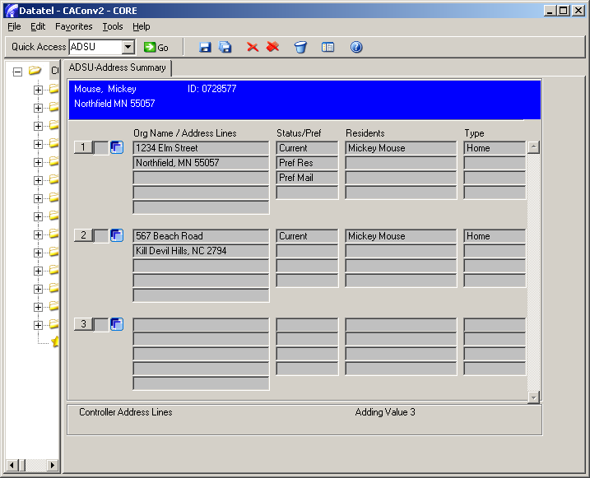
In the example shown above, the person has two current “home” addresses, but only one is his preferred residence and preferred mailing address. That is the one that has an error in the street address. Choose the address to be changed by clicking the blue “detail” button. This takes you to the ADR screen. Make the desired changes in the address and save your changes. You will get a pop-up box like:

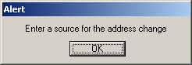

Click “OK” and enter “COR” (for “correction”) in the Change Source field and save your changes. If only one person lives at this address, you will then get a pop-up box:

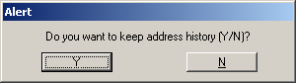

Because you were just fixing an erroneous address, do not keep address history, so click “N”. Save your changes on the ADSU screen; if you cancel out of ADSU, your changes will not be saved.

If more than one person lives at the address you are correcting, after you enter a source for the address change and save your work on ADR, you will get a screen like the following:

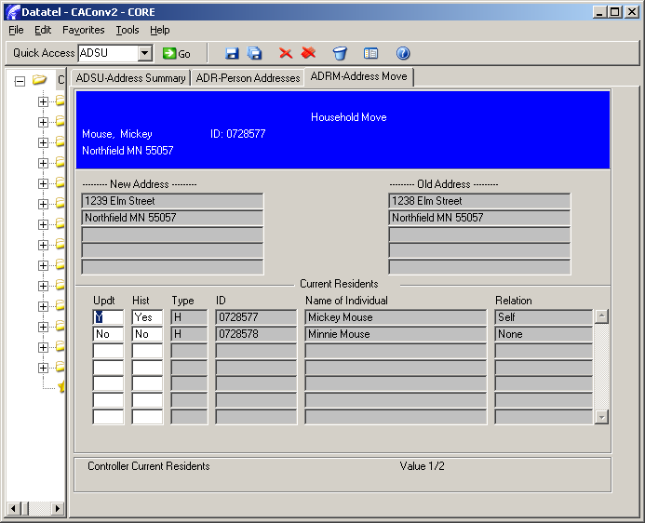

Since all the people are in the same address (which you are correcting), enter “Y” for each person in the “Updt” column (to correct everyone’s address), and enter “N” in the “Hist” column, so that we do not keep the address history:

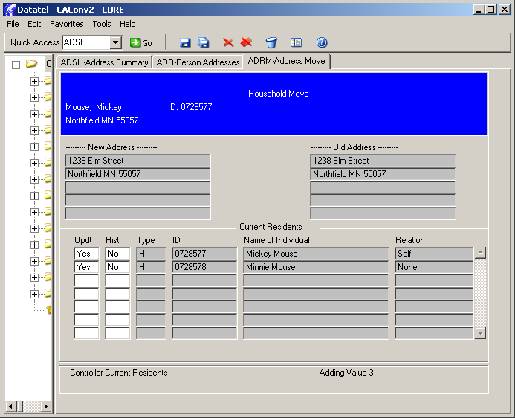

Save your changes on ADRM, and save your changes when you are returned to ADSU.

Remove a “correction” that was mistakenly added to History. In this example there are two addresses listed that are identical, other than the street number. To remove the Former address that was entered incorrectly, detail into the address.

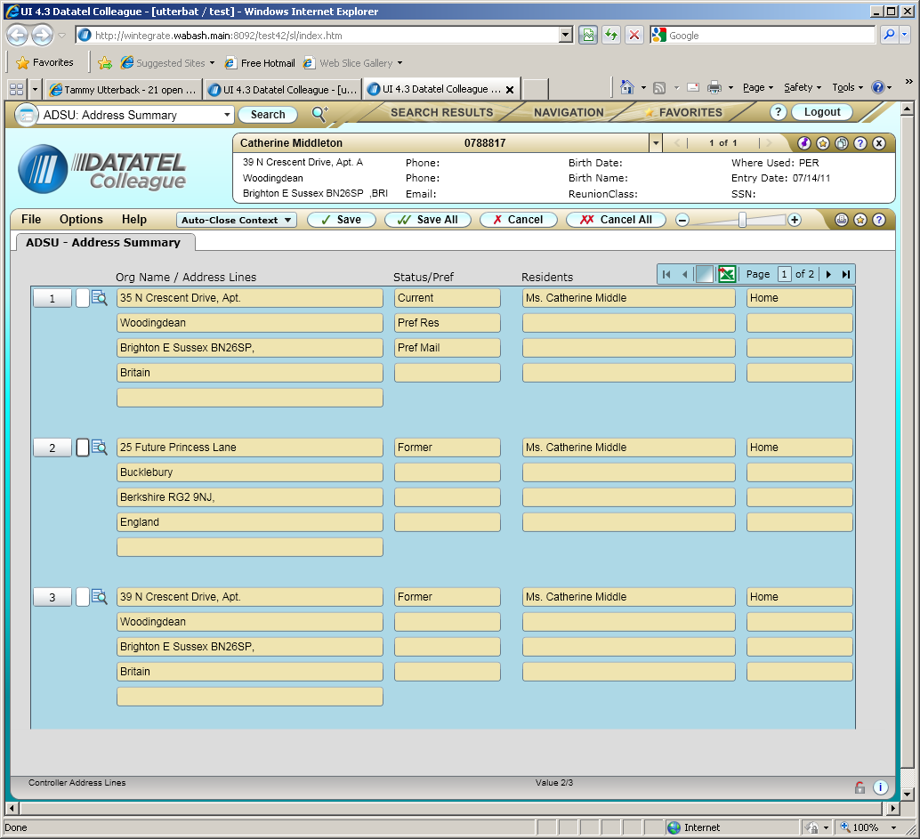

Select CO - Correction for Type field and select Update to update the record.

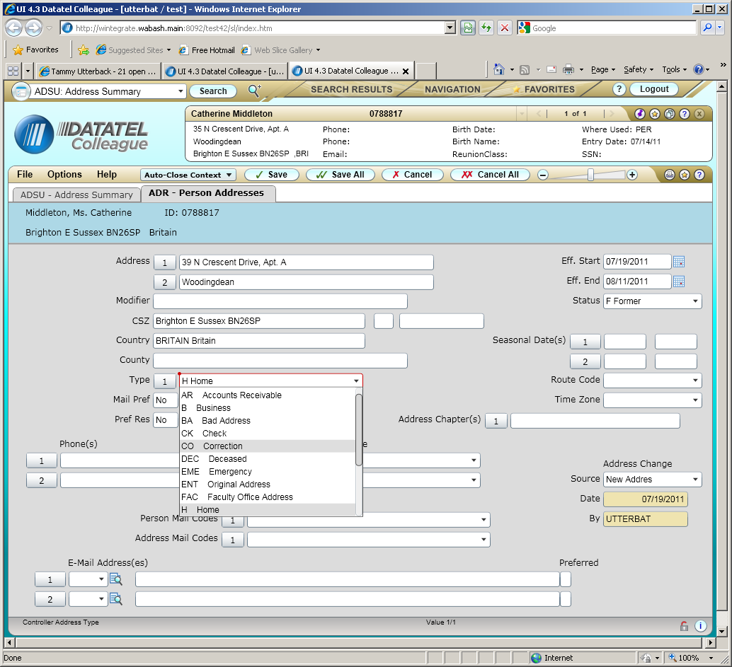

The address will be removed.

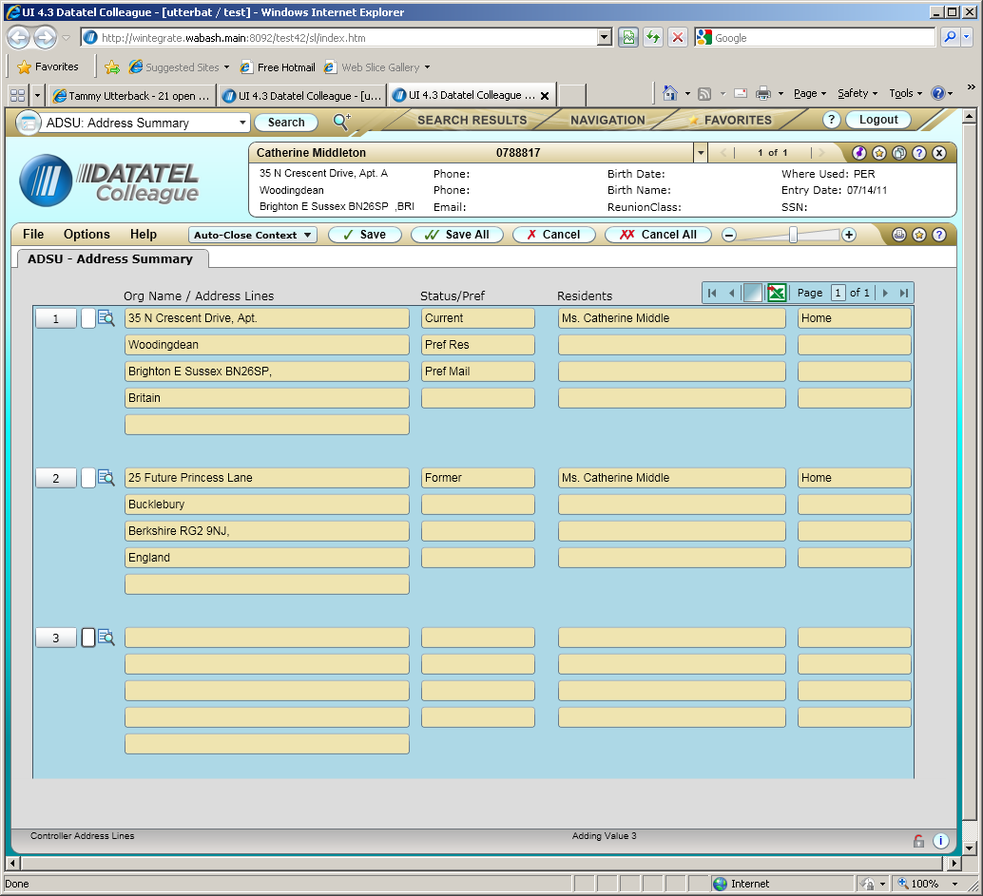

Be sure to save your work from ADSU, because if you cancel, the changes will not be made.
Entering a new address for a person
To enter a new address for a person (when they have moved, for example), call up the person on the ADSU screen. You will see a screen like the following with all of the person’s current and former addresses:
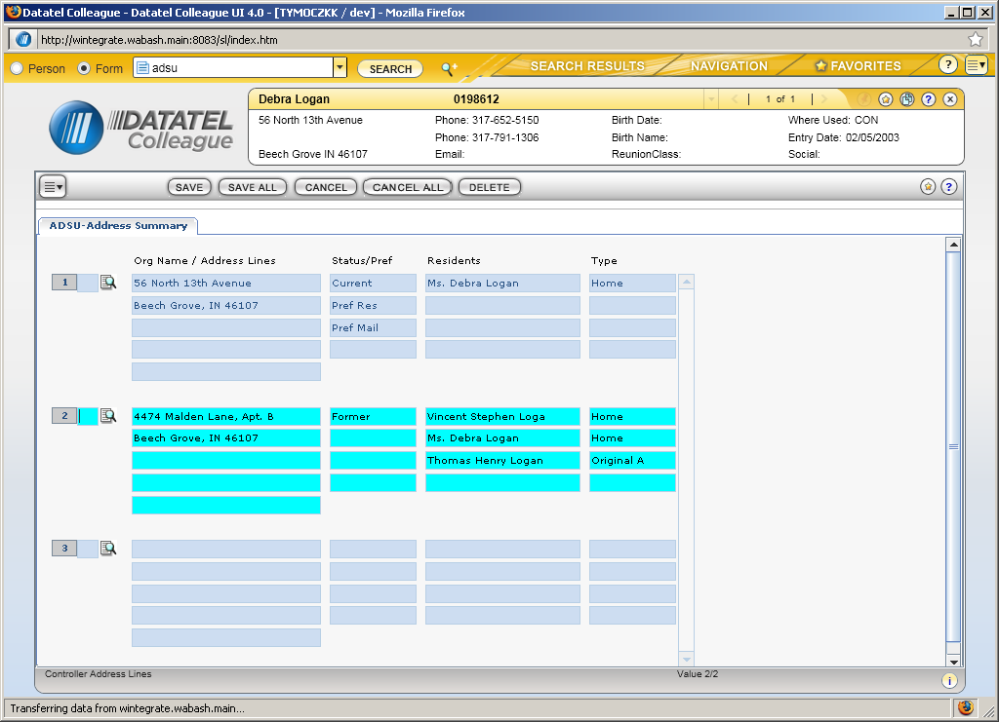

Detail on the current address (the one that will become the former address) to go to the ADR form:
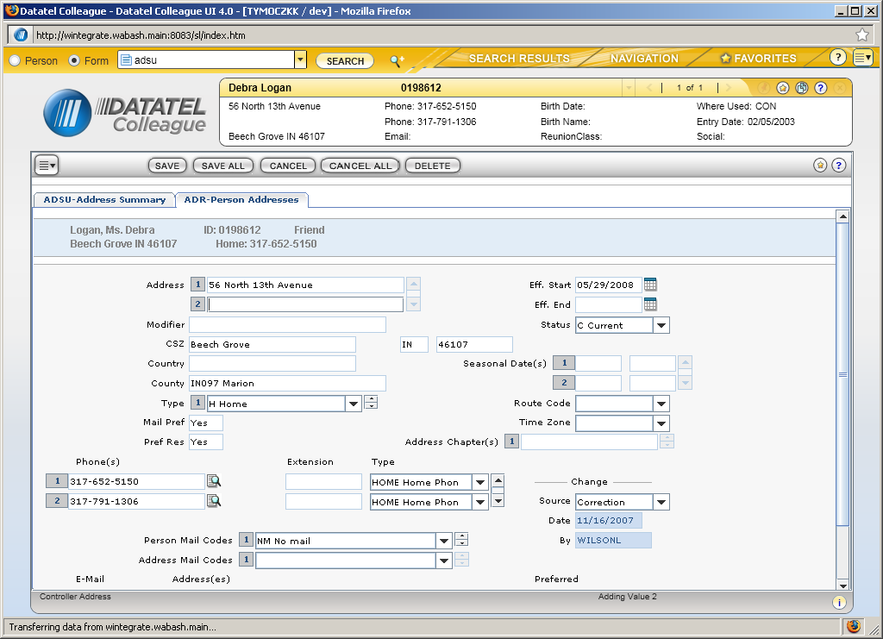

Type over the address fields to be changed and enter the start date of the new address in the “Eff. Start” field. You may also need to change any phone numbers attached to the address (for example, a phone number with a type of “HOME”). Keep in mind when you are changing an address for a current student or an alum, that the old address may have more than one address type, usually “HOME” and “ENT”. The “ENT” address type is the “original address” that the alum or student had when he matriculated. A person should only have ONE address with the “ENT” type, so if the address you are changing has an “ENT” type, you must delete it from the multi-valued “Type” field, so that only the newly former address will have a type of “ENT” and the new address will not. Enter a source for the address change (e.g. “new address” or “returned mail”) in the “Source” field, and save your work. If other family members already reside at the new address, you may get a resolution screen which looks like:
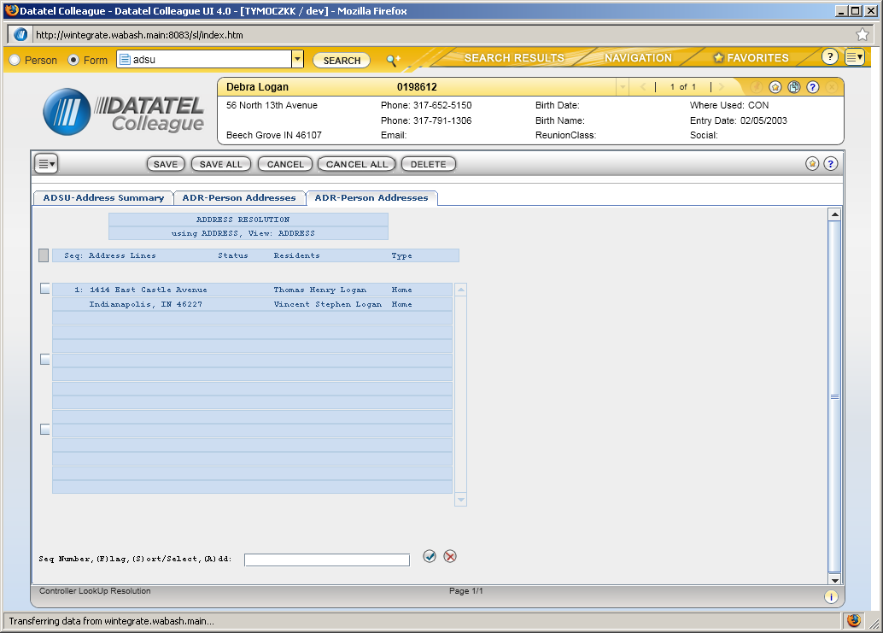

Choose the correct address and save. You will then be asked if you want to keep address history:

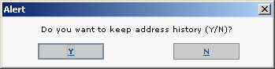

Since this is a new address, choose “Y”. This will make the new address the preferred residence and mailing address, and will make the old address former:
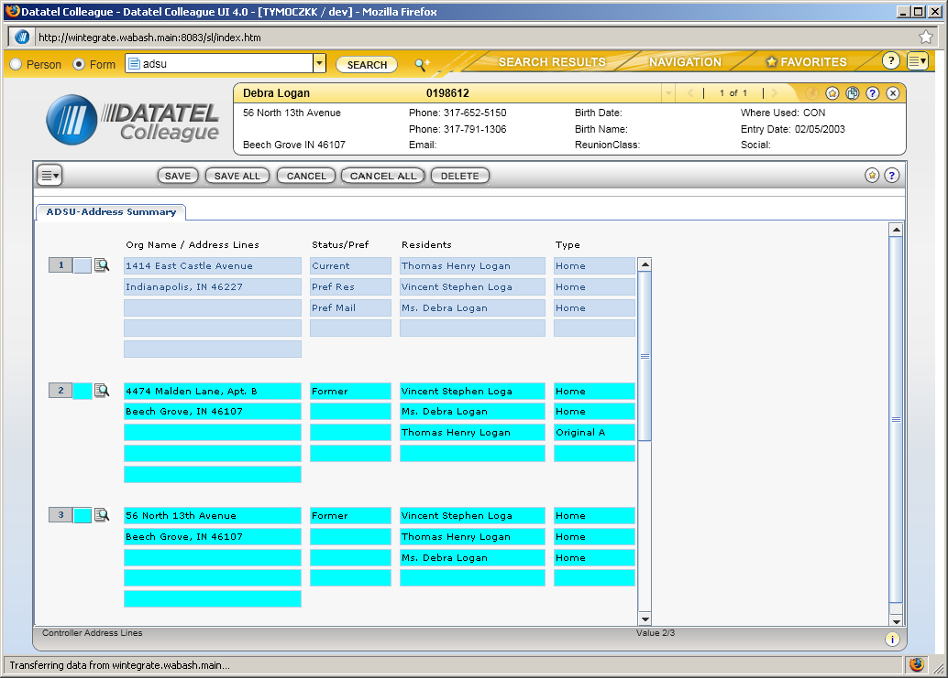

Be sure to save your work from ADSU, because if you cancel, the changes will not be made.
Adding a new student’s parent(s) and parent(s) addresses
A new student’s parents need to be added to Colleague and given a home address as well as related to the new student and to each other when applicable.

- Access the REL screen and look-up the student record.
- In the Parent field do a look-up for the first parent. If a resolution screen returns the correct person, select it, if not, enter A to add and you will be taken to the NAE screen where the student’s address will auto-populate. Complete the screen and save your changes. Since the new student already exists in Colleague, his (and his parents’) address already exists in Colleague. You will get an address resolution screen that looks like:

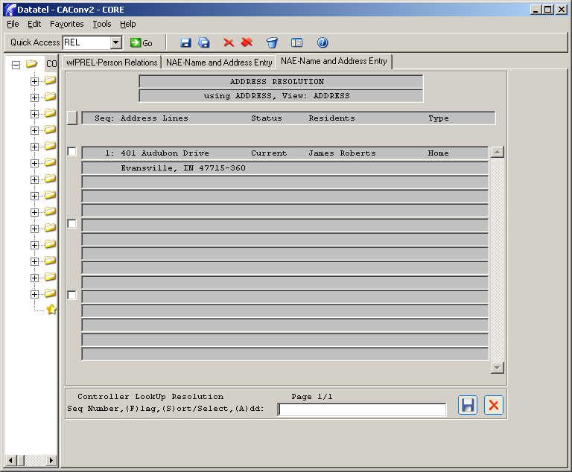

Since the person in the address is the student whose parent is being added, choose this address by typing its number or clicking the box to the left of the address. The parent and student will then be “householded” or share the same address. Note that for international addresses, if the city and postal code were entered as the last of the address lines (rather than in the city field), it will not find the address and the student and parents will not be householded.

- A Relation Types Lookup box will display. This is where you enter the relationship code that this person is to the new student. Enter P for Parent or SP for Step-parent. You will now be on the RELE screen. Save your changes and you will be returned to the REL screen. Repeat steps 2 & 3 for the other parent if applicable.
- Save from REL

Now you need to “marry” the new parent records when applicable. To do this:

- Access the REL screen and look-up the “male” record
- In the spouse field look-up the spouse record
- On the RELE screen, detail on the Joint Mailing field to go to the JTML screen
- Enter Yes in the Joint Mail and Joint Solicitation fields and save your changes.
- Save your changes on the RELE screen
- Save your changes on the wfPREL (REL screen)

Now you should make sure that all family members have been related. To do this:

- Access the FAMD screen and look-up one of the parent records
- Complete the screen as necessary being sure to detail on the Manage sibling relationships field if the box has an X in it.
- Save your changes.

Making a “former” address a “current” address
Occasionally an address change will come through for a person that is the same address as a former address. Use the ADSU screen to call up the person. You will get a screen which shows all of the person’s addresses, both current and former:

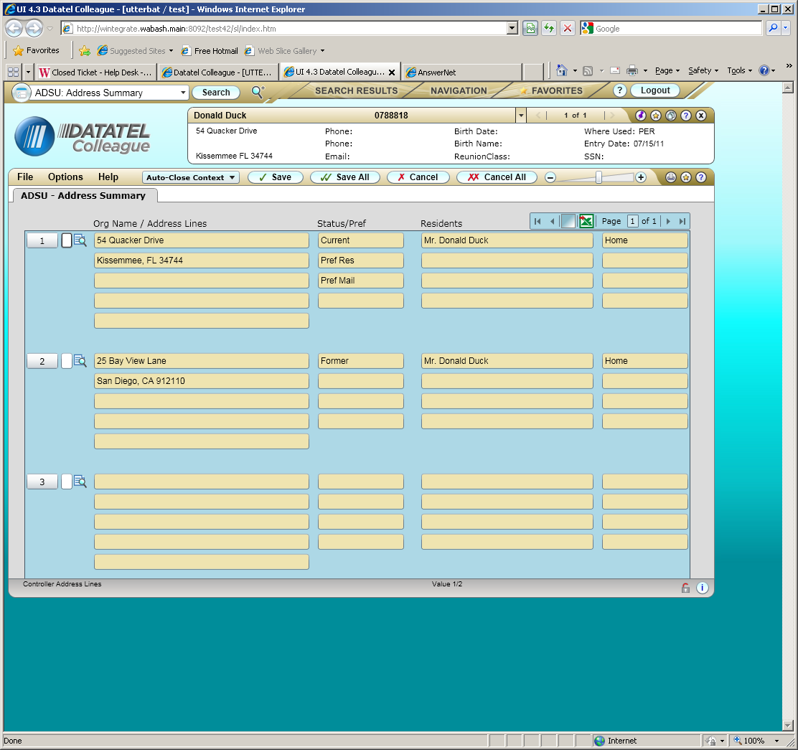

Detail on the current address (the one that will become the former address) to go to the ADR form.

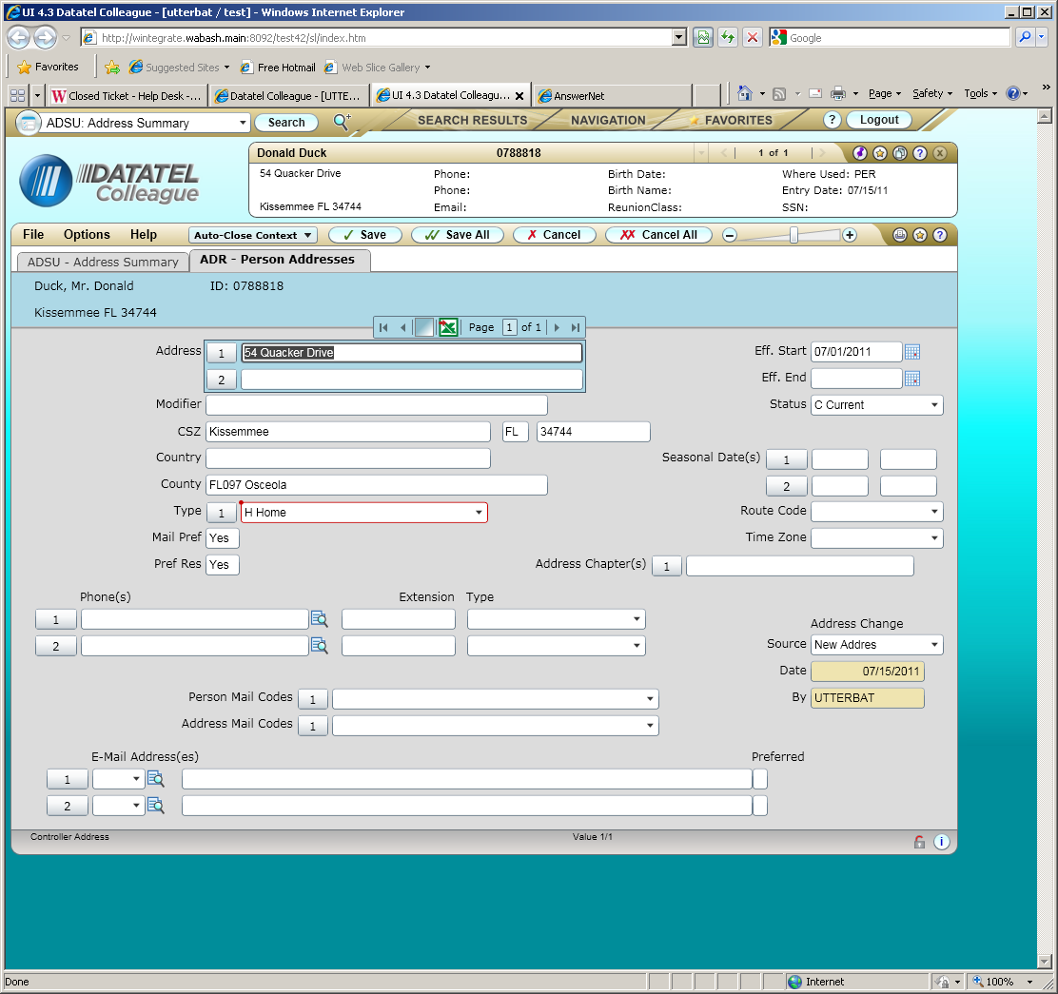

Type over the address fields to be changed and enter the start date of the new address in the “Eff. Start” field. Enter a source for the address change (e.g. “new address” or “returned mail”) in the “Source” field, and save your work.

The Address Resolution screen will appear with the “Former” address. DO NOT select the address displayed, but enter an “a” for Add in the “Select #:” field as shown below:

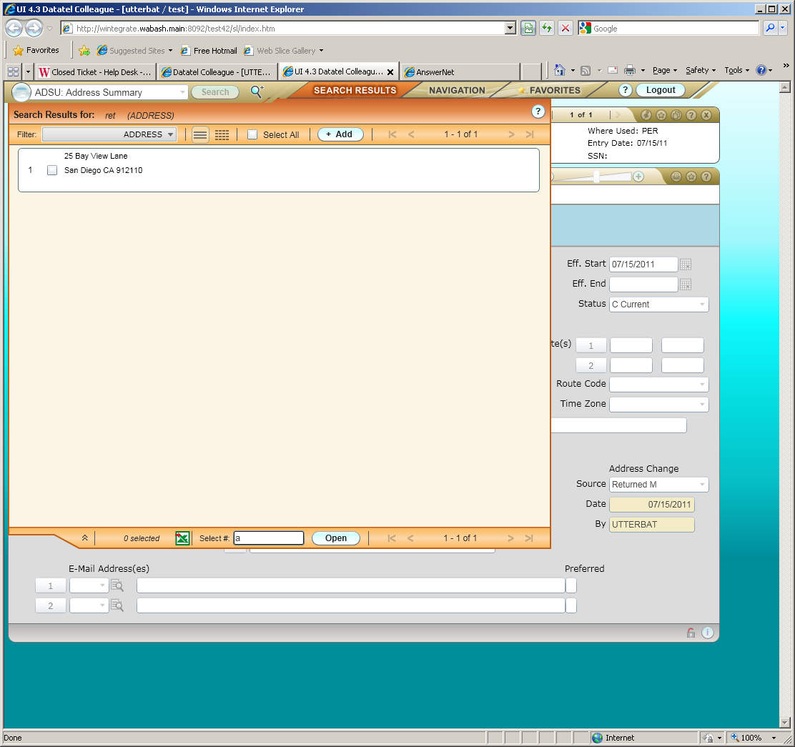

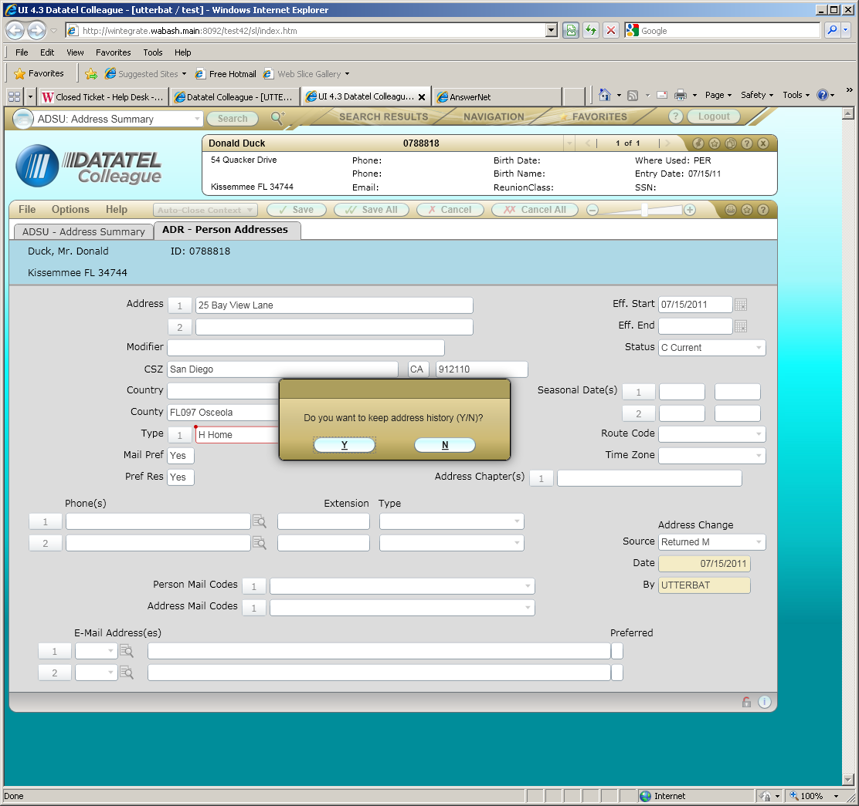

“Do you want to keep history?”, select “Y” and complete the ADRM (Address Move) screen as necessary.

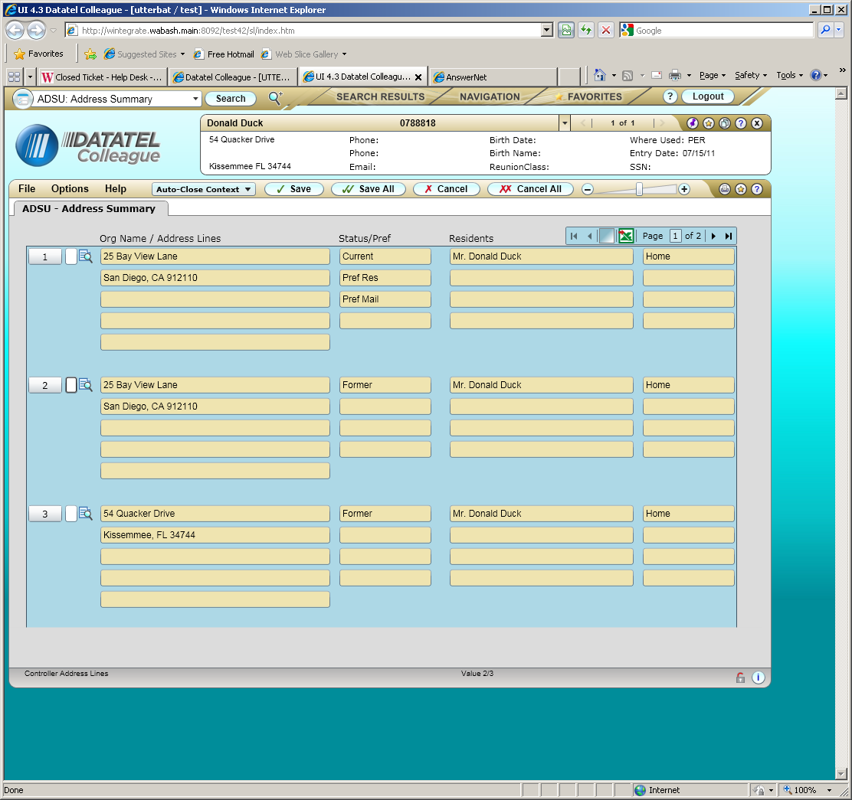

Be sure to save your work from ADSU, because if you cancel, the changes will not be made.

“Room Assignment” addresses, such as the one shown below, are not maintained using ADSU. Please contact the Dean of Students office for any corrections.

